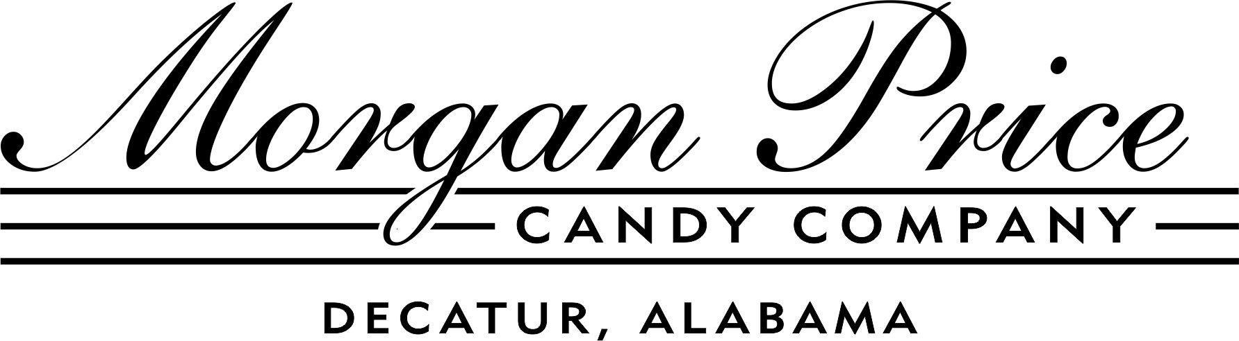
PEEPS® Contest 2013

Entry Form

Name (s) _____________________________________________

Age (s) ______________________________________________

Address _____________________________________________

City __________________State ________________Zip ______

Phone _______________________________________________

Exhibit Title___________________________________________

Brief Description:

PEEPS® and the PEEPS® Chick and Bunny shapes are trademarks of Just Born, Inc., Bethlehem, PA. © All rights reserved.

